Lab: Basic SSRF against the local server

Open the burpsuite and turn on the intercept in the proxy. Check the stock and forward that request from the proxy to repeater. Now change the value of stockApi to http://localhost/admin. Send the modified request and now you will get the admin panel but will not be able to delete the user carlos. Read the url and understand it to modify the url similarly and pass the modified url to the stockApi field and the user carlos will be deleted.

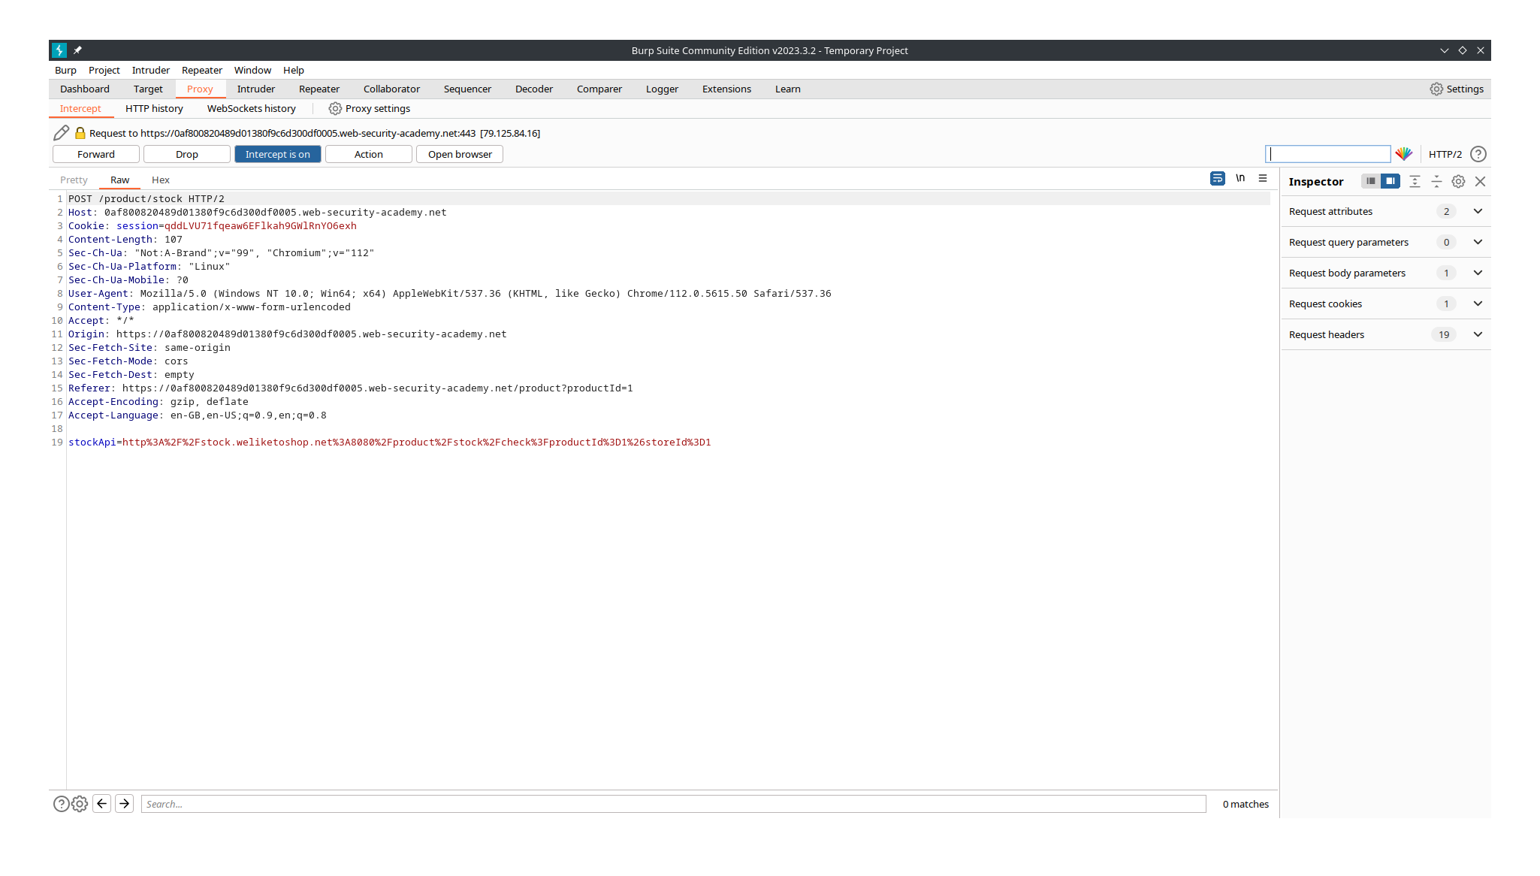

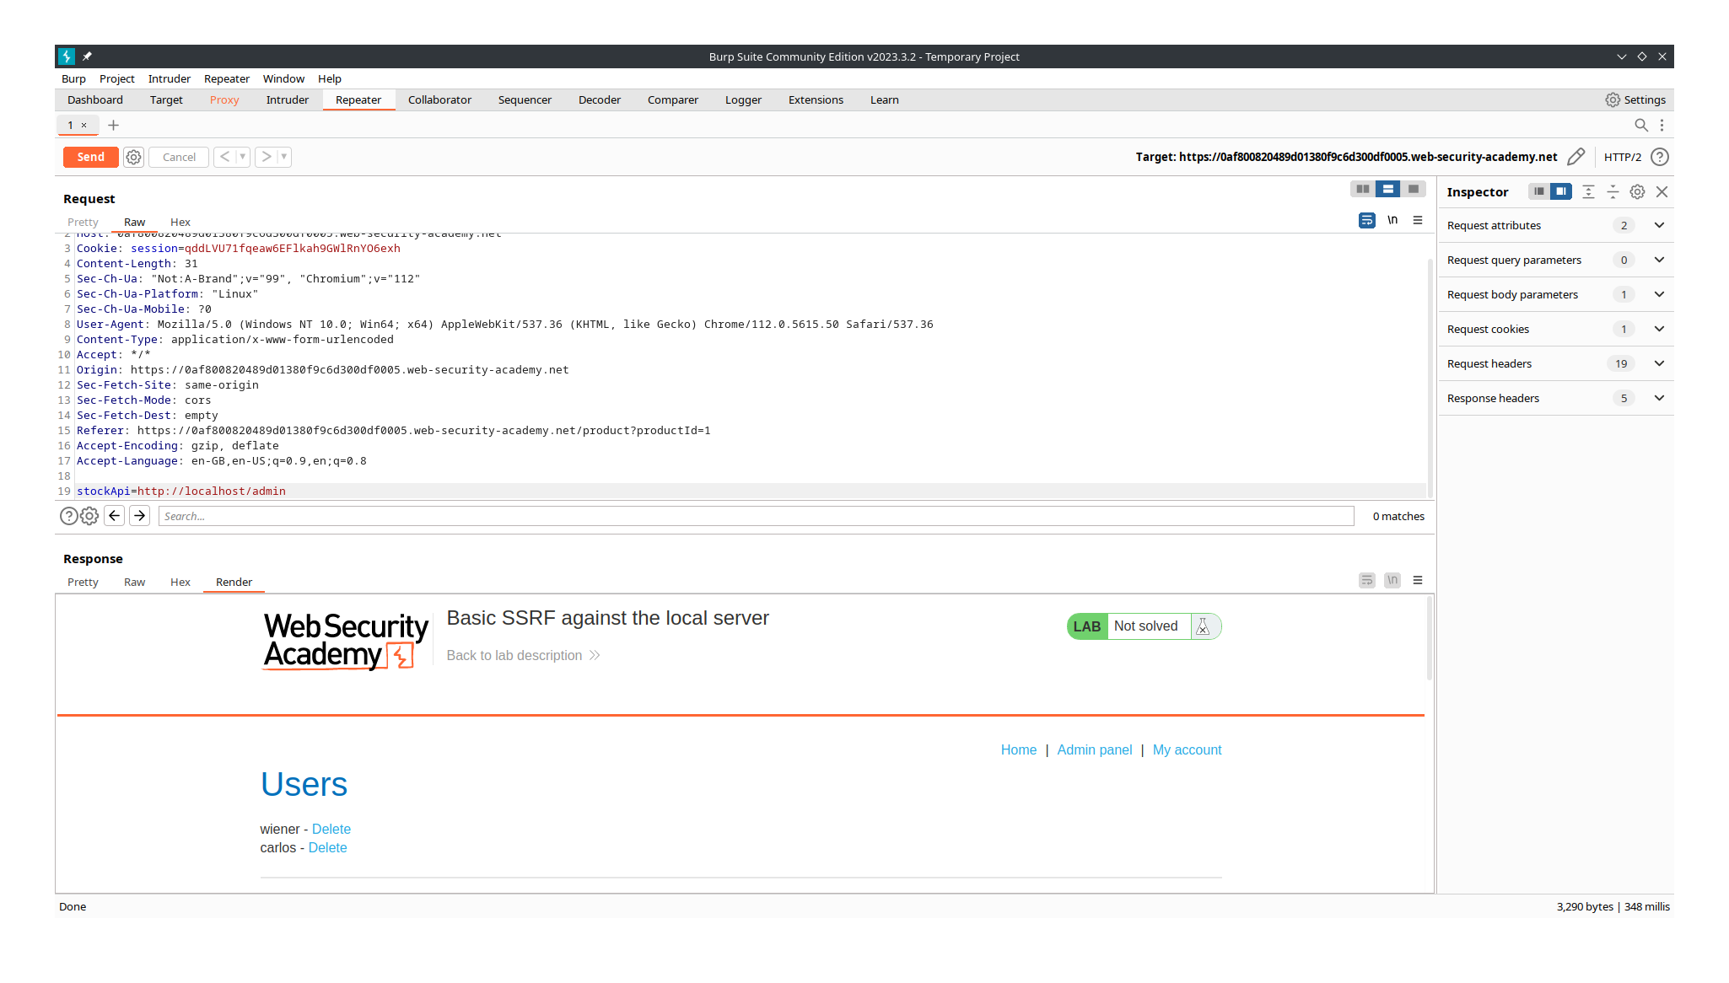

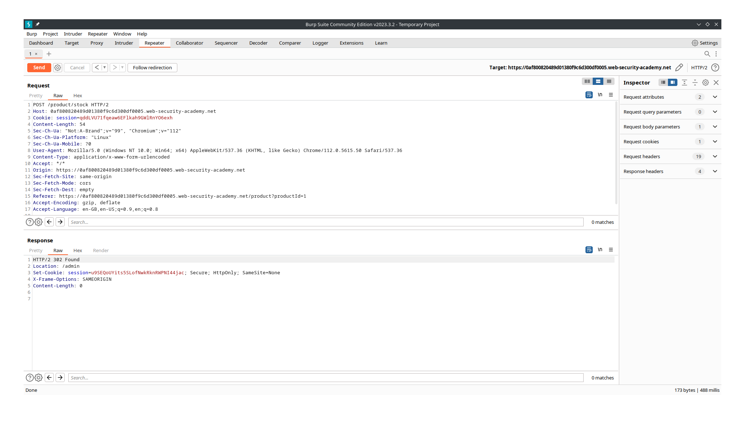

Lab: Basic SSRF against another back-end system

Open the burpsuite and turn on the intercept in the proxy. Check the stock and forward that request from the proxy to intruder. Now try the sniper attack on the last octet of the given ip address form 0 to 255. There will status code for only one number and send that request to the repeater. Send the modified packet and now you will get the admin panel but will not be able to delete the user carlos. Read the url and understand it to modify the url similarly and pass the modified url to the stockApi field and the user carlos will be deleted.

